***The Recognition and Enhancement of Traffic Speed Limit Sign for the Computer Generated Image***

**A Project Report**

*Submitted in partial fulfilment for the award of the degree*

*of*

**MS**

***in***

**Software engineering**

*by*

**SARANAM HARSHA VARDHAN GUPTA(11MSE0032)**

**MAREPALLY VARUN KUMAR(11MSE0117)**

*Under the guidance of*

**Prof.J.Kamalakannan**

**Assistant Professor (Sr),SITE,**

**VIT University**



**School of Information Technology and Engineering**



**School of Information Technology and Engineering**

**DECLARATION BY THE CANDIDATE**

I hereby declare that the thesis entitled “***The Recognition and Enhancement of Traffic Speed Limit Sign for the Computer Generated Image*”** submitted by me to VIT University Vellore, in partial fulfillment of the requirement for the award of the degree of **MS-Software Engineering** is a record of bonafide project work carried out by me under the supervision of **Prof.J.Kamalakannan**. I further declare that the work reported in this project has not been submitted and will not be submitted, either in part or in full, for the award of any other degree or diploma in this institute or any other institute or university.

**Place**: Vellore

**Date**: **Signature of the Candidate(s)**



**School of Information Technology and Engineering**

**BONAFIDE CERTIFICATE**

This is to certify that the project work entitled “***The Recognition and Enhancement of Traffic Speed Limit Sign for the Computer Generated Image*”** by **Saranam Harsha Vardhan Gupta** to VIT University, Vellore, in partial fulfillment of the requirement for the award of the degree of **MS-Software Engineering**, is a record of bonafide work carried out by her under my supervision. The project fulfills the requirement as per the regulations of this Institute and in my opinion meets the necessary standards for submission. The contents of this report have not been submitted and will not be submitted either in part or in full, for the award of any other degree or diploma in this Institute or any other Institute or University.

**Prof.J.Kamalakannan,**

**Assistant Professor(Sr),**

**SITE,**

**VIT University.**

**Internal Examiner(s) External Examiner(s)**

**Acknowledgement**

I wish to express our heartfelt gratitude to **Dr.G.Viswanathan**, President/ Chancellor, Vellore Institute of Technology University, Vellore for providing facilities for the fourth semester project.

I am highly grateful to our Vice Presidents, **Shri. SankarViswanathan** ,

**Shri.SekarViswanathan and Shri.G.V.Selvam**, **Dr. V. Raju,** Vice Chancellor, **Dr.S. Narayanan,** Pro-Vice Chancellorfor providing necessary resources.

My sincere gratitude to **Dr.K.Ganesan,**Dean(i/c), School of Information Technology and Engineering for giving us the opportunity to undertake the project.

I wish to express my sincere gratitude to **Prof.R.Srinivasaperumal**

Programme Manager of M.S-SE, and **Prof.N.Manikandan** project coordinator/MS School of Information Technology and Engineering for providing me an opportunity to do my project work in the VIT University*.*

I would like to express my special gratitude and thanks to my internal guide

**Prof.Kamalakannan,** School of Information Technology and Engineering whose esteemed guidance and immense support encouraged to complete the project successfully.

I thank the Management of VIT University for permitting me to use the library resources. I also thank all the faculty members of VITUniversityfor giving me the courage and strength I needed to complete my goals. This acknowledgement would be incomplete without expressing my whole hearted thanks to my familyand friends who motivated me during the course of the work.

I thank the Almighty, whose showers of grace were felt during the entire course of my project.

Place: Vellore Saranam Harsha Vardhan Gupta

Date:10-11-2014 Marepally Varun Kumar

**TABLE OF CONTENTS**

|  |  |  |
| --- | --- | --- |
| **CHAPTER NO.** | **TITLE** | **PAGE NO.** |
|  |  |  |
|  | **ABSTRACT** | vii |
|  | **LIST OF TABLES** | viii |
|  | **LIST OF FIGURES** | ix |
|  | **LIST OF Abbreviations** | x |
|  |  |  |
| 1 | **INTRODUCTION** |  |
|  | 1.1 | 2 |
|  | 1.1.1…………… | 3 |
|  |  | 3 |
|  |  | 3 |
|  |  | 4 |
|  |  | 4 |
|  |  | 4 |
|  |  | 4 |
| 2 | **literature survey** |  |
|  |  | 6 |
|  |  | 7 |
|  |  | 8 |
|  |  | 8 |
|  |  | 11 |
|  |  | 11 |
|  |  | 12 |
|  |  | 16 |
|  |  | 16 |
|  |  | 17 |
| **CHAPTER NO** | **TITLE** | **PAGE NO** |
|  |  | 18 |
|  |  | 18 |
|  |  | 19 |
|  |  | 20 |
|  |  | 21 |
|  |  | 21 |
|  |  | 21 |
|  |  | 22 |
|  |  | 22 |
|  |  | 22 |
|  |  | 22 |
| 3 | **SYSTEM DESIGN** |  |
|  | 3.1 Overview | 23 |
|  | 3.2 Proposed Strategy | 24 |
|  | 3.2.1……… | 24 |
|  | 3.2.2 ……… | 27 |
|  | 3.2.3 | 28 |
| 4 | **IMPLEMENTATION OF THE SYSTEM** |  |
|  | 4.1 Module Description | 32 |
|  | 4.2 Programming Language Details | 34 |
| 5 | **RESULTS AND DISCUSSION** | 34 |
|  | 5.1 Advantages of Proposed System | 35 |
|  | 5.2 Screenshots | 37 |
| 6 | **CONCLUSION AND FUTURE WORK** |  |
|  | 5.1 Conclusion | 46 |
|  | 5.2 Future Work | 46 |
|  | **APPENDIX** | 47 |
|  | **REFERENCES** | 61 |

**ABSTRACT**

Image recognition in image understanding is very challenge research topic. However, the study of recognition and enhancement of the specific target for the computer generated image is very less. For recognition and enhancement of the specific target (such as traffic sign) in the computer-generated image, the difficulty is how to accurately recognize and enhance the specific target, and maintaining other information of object do not been changed. Utilizing appropriate image enhancement techniques we can clearly reduce the task of the driver in recognizing the speed limit of the road and making sure that the driver is not exceeding the specified speed limit without much effort from the respective driver.

**1.INTRODUCTION:**

**1.1.AIM:**

To detect the “speed limit” of the road from the image of the traffic sign board using image enhancement and segmentation techniques.

**1.2.SCOPE:**

This system when incorporated in the vehicle helps the driver to know about the speed limit of the road without prior observation. This intimation may help the driver in reducing the speed of the vehicle corresponding to the speed limit of the road. The system may be extended further for all the traffic signs detection which in turn acts as a “**third eye"** for the driver.

This system can also be helpful in developing the automated vehicles (Driver less vehicles) in the near future in order to respond accordingly to the traffic signs by detecting them.

**2.LITERATURE SURVEY:**

**2.1. Efficient Recognition of speed limit signs.**

Author : Jim Torresen, Jorgen W. Bakke and Lukas Sekanina.

Publication : IEEE Intelligent Transportation Systems Conference ,2004.

Description : The detection of the sign is done in 3 steps namely image filtering based on the color, locating the sign in the image and the detection of numbers in the sign. This method mainly concentrated on the reduction of time for processing the image and also high recognition performance.

**2.2.Speed Limit Traffic Sign Detection and Recognition.**

Author :Yasser Baleghi Damavandi and Karim Mohammaddi

Publication :IEEE Conference on Cybernetics and Intelligent Systems,2004.

Description : The preprocessing of the image involves the red color filtering. Even though the HSI color space model provides with brightness variation and robustness they have chosen YCbCr color space as it provided with the better practical results (Red chrominance). The red filtering is done and the circles in the images are detected using the Hierarchical Hough Transform (HHT). Then the resulting image is trained by specific set of inputs and recognized.

**2.3.** **Efficient Technique for Color Image Noise Reduction.**

Author : C.Mythili, Dr.V.Kavitha

Publication : The Research Bulletin of Jordan ACM, Vol. II (III)

Description : This paper provides with what are the different kinds of noises produced in the image and how the nature of noise removal problem depends on the type of noise corrupting the image. It also provides with the different kinds of linear and nonlinear filters that can be used in order to remove the noise from the corrupted image. The comparison of results of different noise removal filters is also done.

**2.4. Detection and recognition of speed limit signs.**

Author : Yea-Shuan Huang,Yun-shin-lee

Publication : IEEE,2010.

Description :This speed limit sign board detection uses Adaboost algorithm and Circular Hough Transform (CHT) in order to detect the red circle in the image. Then the numerical part in the speed limit sign is detected based on the white background. The numerical part of the image is highlighted using sharpening filters. Now coming to the numerical part capture the segmentation is done based on the component labeling. The numerals are detected based on the training set.

**2.5. Robust on-vehicle real-time visual detection of American and European speed limit signs ,with a modular Traffic Signs Recognition system.**

Author : Fabien Moutarde, Alexandre Bargeton, Anne Herbin, and Lowik Chanussot

Publication : IEEE Intelligent Vehicles Symposium,2007

Description : In this paper, we present robust visual speed limit signs detection and recognition systems for American and European signs. Both are variants of the same modular traffic signs recognition architecture, with a sign detection step based only on shape-detection (rectangles or circles), which makes our systems insensitive to color variability and quite robust to illumination variations. Instead of a global recognition, our system classifies (or rejects) the speed-limit sign candidates by segmenting potential digits inside them, and then applying a neural network digit recognition. This helps handling global sign variability, as long as digits are properly recognized.

**2.6. Method for Recognition of Numbers on Speed Limit Signs Utilizing an Eigen Space Method Based on the KL Transform.**

Author : Shigeharu Miyata, Shin Takehara, Hideki Sakai,Takahiro Ishkawa

Publication : ICARCV-International Conference on Control, Automation, Robotics & Vision,2012

Description : This method uses Eigen spaces and values obtained from the KL transform for automatic recognition by camera. The system provides with the efficient, fast and accurate recognition of the still images. It has also extended for the images with certain angle. The image acquired from the camera uses a RGB color system. In order to obtain the hue system the image is converted to HSV (Hue, Saturation, and Value) color system. The resulting image is expressed as independent H, S, V parameters, providing color information that is highly robust in terms of brightness.

**2.7.** **North-American Speed Limit Sign Detection and Recognition for Smart Cars.**

Author : Abdelhamid Mammeri, Azzedine Boukerche, Jingwen Feng and Renfei Wang

Publication :IEEE International Workshop on Performance and Management of Wireless and Mobile Networks.

Description :This system is for the North American Sign boards. The sign board is detected in the image based on the color of the sign board or on the basis of shape of the sign board and accordingly use the color based segmentation or shape based segmentation respectively. After the detection of the sign in the image the recognition of the speed limit is done based on HOG (Histogram of Oriented Gradient) in order to detect the speed limit precisely.

**3.SYSTEM DESIGN:**

**3.1.Architecture:**

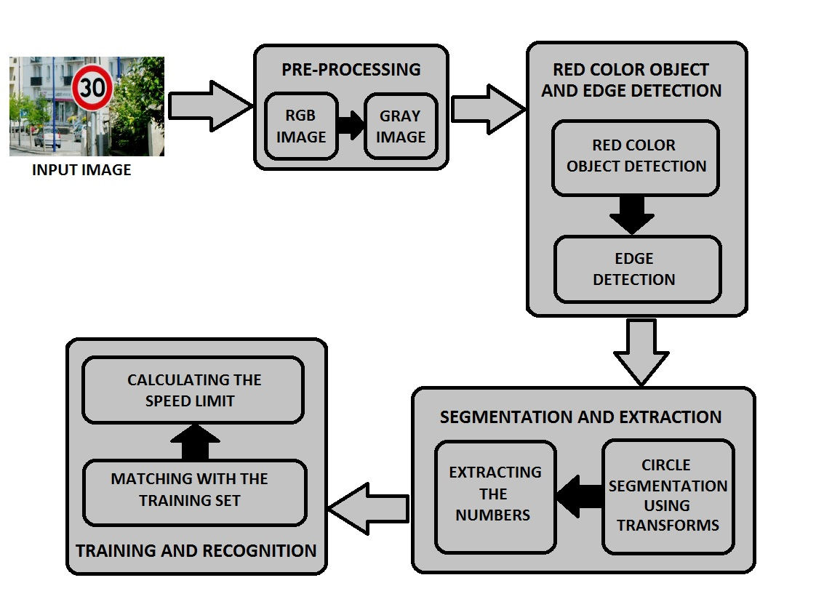

**3.2.Detailed Design:**

**3.2.1.USE CASE diagram:**

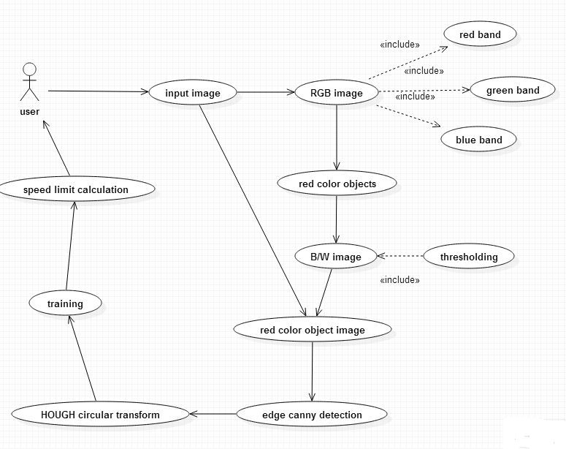

The use case diagram provides with the interaction of the user with the system. How the process is carried out with (one after the other). It provides with good communication to the expert users and stakeholders.

**3.2.2.DATA FLOW diagram:**

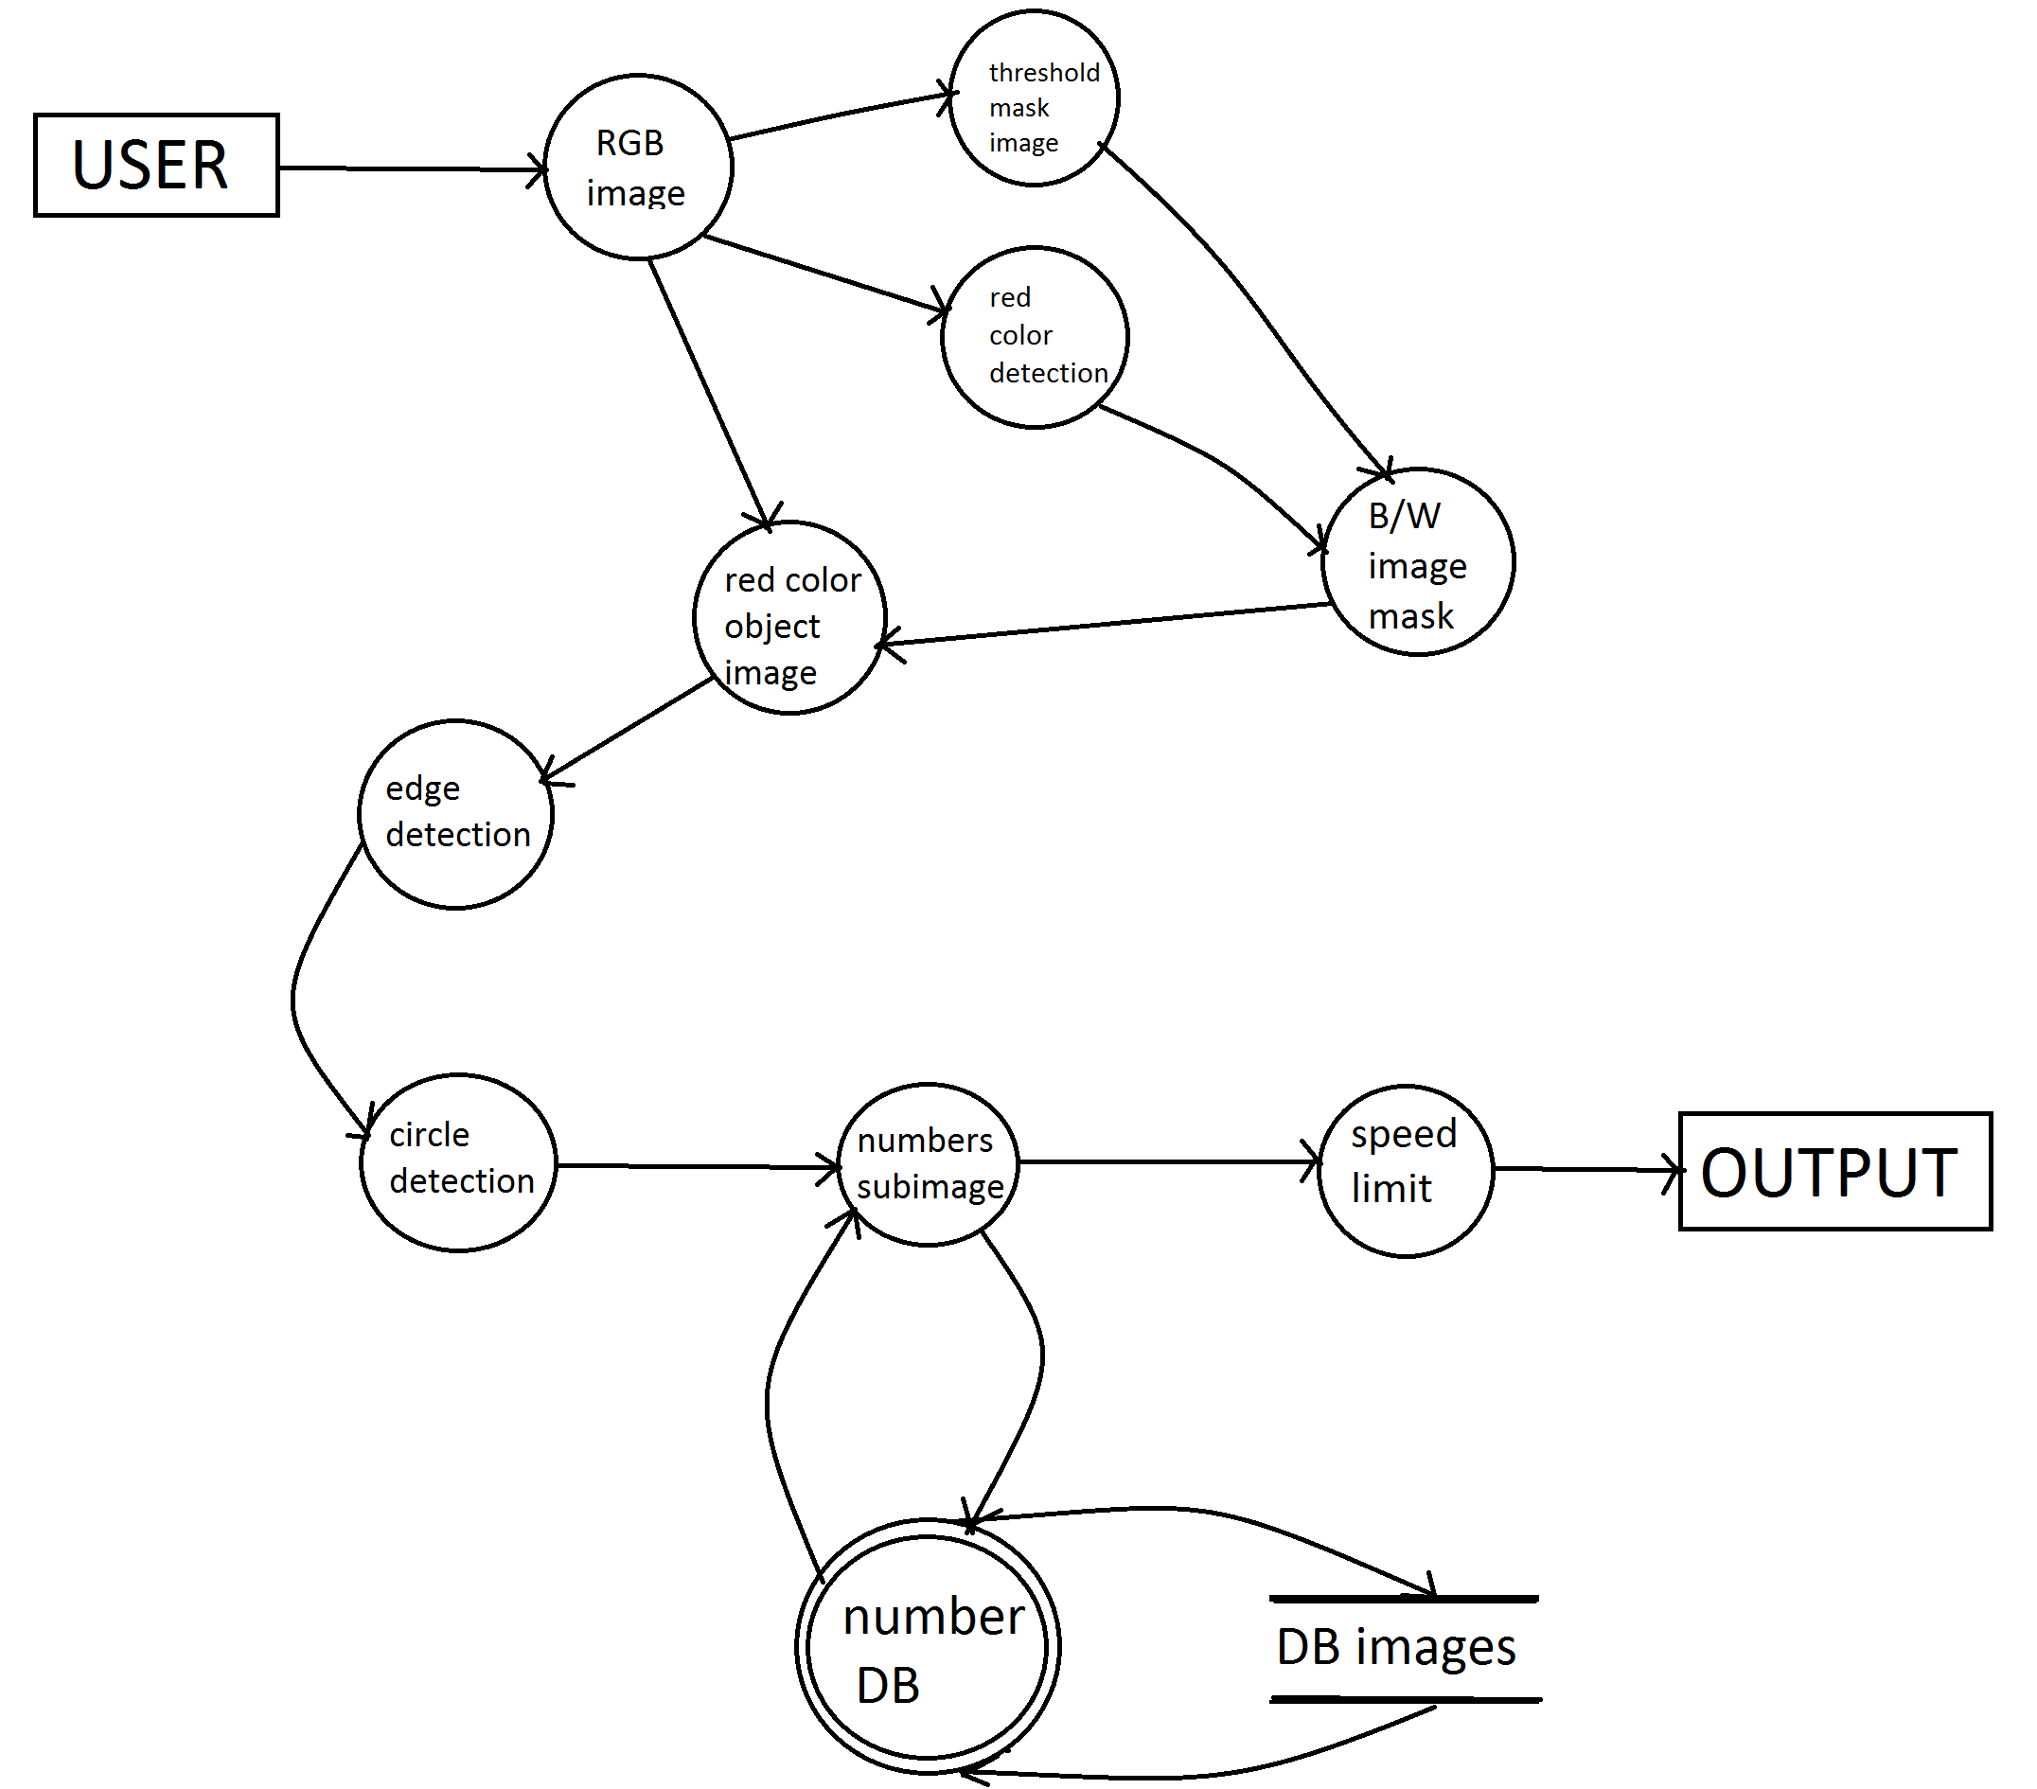

**3.2.2.Activity Diagram:**

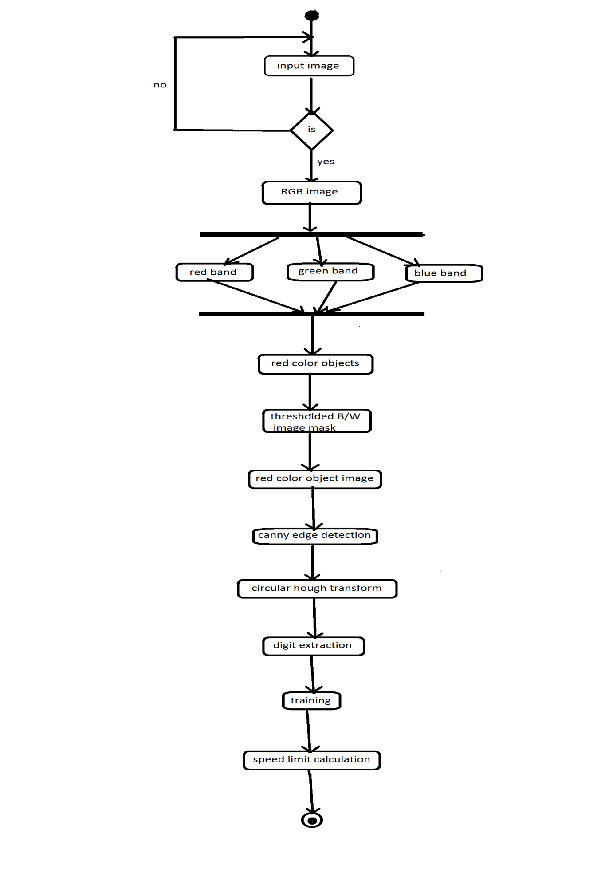

**4 . IMPLEMENTATION OF THE SYSTEM:**

**4.1.Modules:**

**4.1.1.Pre-processing:**

The frame obtained from the video coverage is considered as the input image. The image is preprocessed from any of the image form into RGB image using the conversion the conversion techniques. Then the image is converted into the grey scale depending on the R, G, and B values for the further processing.

Eg.Gray scale Image = (R+G+B)/3

**4.1.2.Red color object and edge detection:**

The red color object present around the speed limit is to be detected based on the histogram generated for the image or detecting the red color object using operators. Different techniques may be used in order to detect the red color object. Generally the red color object is in the circular shape. So the red color object detection may be done based on the circular shape in the image or presence of red color in the image.

When the red color object is detected in the image, the edge of the image is to be detected using any of the operators based on the input image (Sobel, Prewitt, Roberts). The detection of edges is to be done in the precise way so that the extraction and segmentation of the image can be done correctly.

**4.1.3.Segmentation and extraction:**

The red color object portion is extracted from the original imageusing transform (like “Hough transform”). The circle is detected using any of the transforms and the co-ordinates are known. Based on the co-ordinates of circle the image is extracted.

The extracted image is scanned pixel by pixel and the images and labeling is done using any labeling technique so as to segment the numbers present inside the circle based on the labels. Depending on the labels assigned the numerals in the speed limit are segmented and saved.

**4.1.4.Training and recognition:**

The segmented parts of the image considered for any noise removal using any of the filters (median filter, adaptive median filter etc.) which is suitable for the image. The noise removal is to be done so as to make the segmented image to match in the training set in the database. Then the pattern of the segmented image is matched with the training set of images and the numerals are detected based on the amount of similarity (70%-80%). Then all the segmented images are recognized and speed limit of the road is known. The speed limit detected is intimated to the driver.

**4.2.Programming language details:**

**5.RESULTS AND DISCUSSION:**

**5.1.Advantages of proposed system:**

**5.2.Screen Shots:**

**a)**

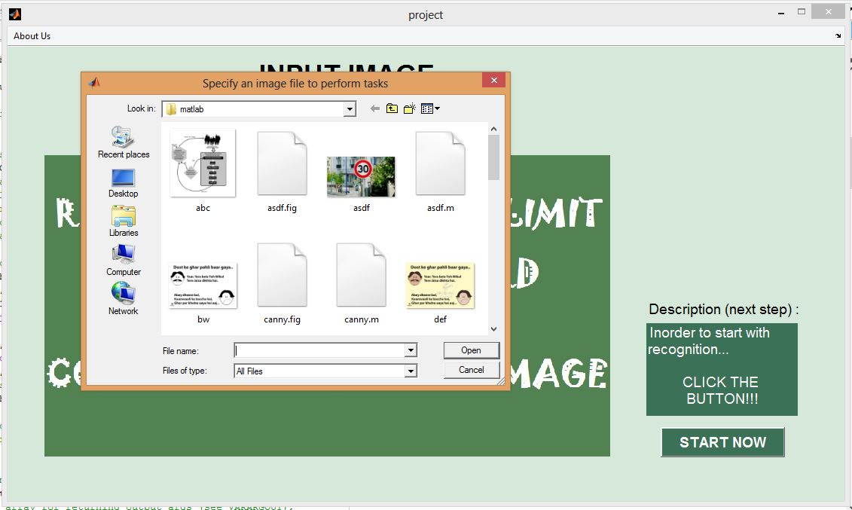

**b)**

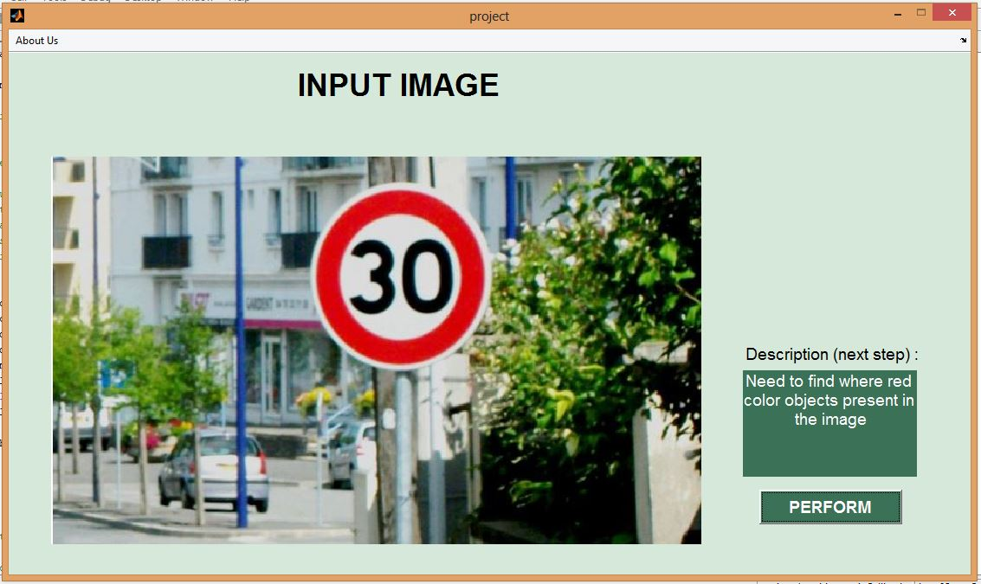

**c)**

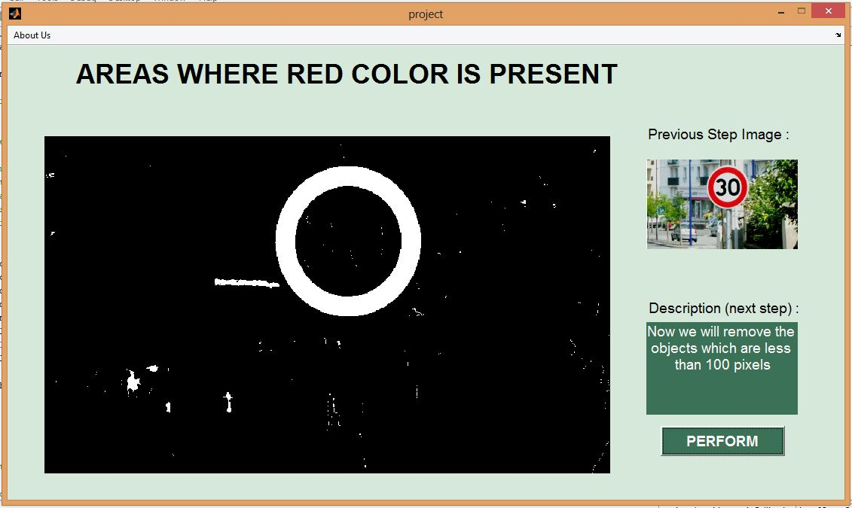

**d)**

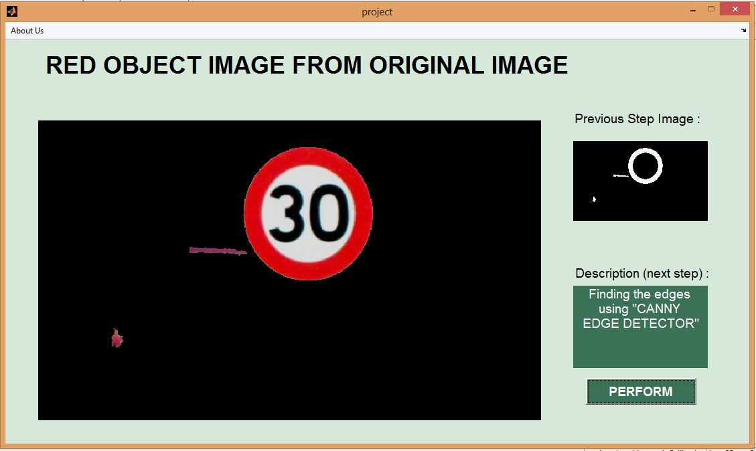

**e)**

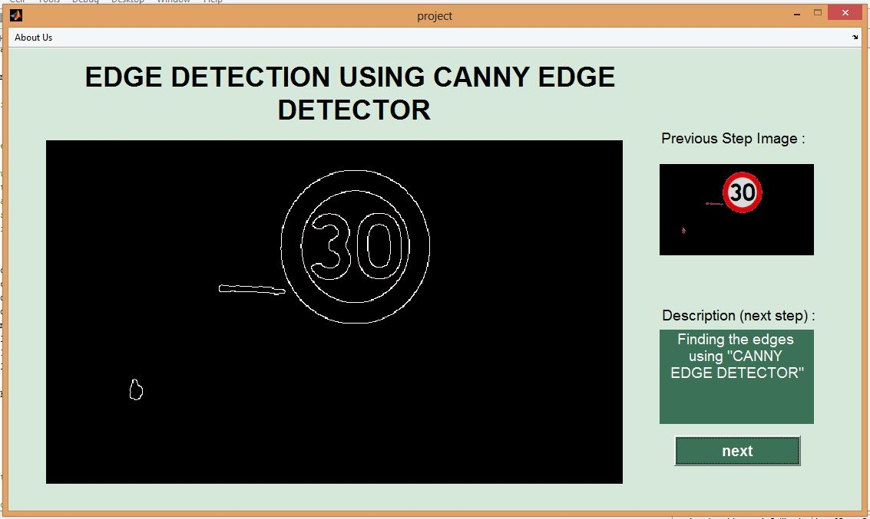

**6.CONCLUSION AND FUTURE WORK:**

**6.1.Conclusion:**

**6.2.Future Work:**

**REFERENCES:**

1. Efficient Recognition of Speed Limit Signs

Jim Torresen, Jorgen W. Bakke and Lukas Sekanina , 2004 , IEEE.

2. Speed Limit Traffic Sign Detection & Recognition

Yasser Baleghi Damavandi,Karim Mohammaddi , 2004 , IEEE.

3. Robust on-vehicle real-time visual detection of American and European speed limit signs, with a modular Traffic Signs Recognition system.

Fabien Moutarde, Alexandre Bargeton, Anne Herbin and Lowik Chanussot

2007, IEEE.

4. DETECTION AND RECOGNITION OF SPEED LIMIT SIGNS

Yea-Shuan Huang,Yun-shin-lee , 2010 , IEEE.

5. Efficient Technique for Color Image Noise Reduction

C.Mythili, Dr.V.Kavitha-The Research Bulletin of Jordan ACM, Vol. II (III) .

6. Method for Recognition of Numbers on Speed Limit Signs Utilizing an Eigen Space Method Based on the KL Transform

Shigeharu Miyata, Shin Takehara, Hideki Sakai, Takahiro Ishkawa , 2012 , IEEE.

7. North-American Speed Limit Sign Detection and Recognition for Smart Cars

Abdelhamid Mammeri, Azzedine Boukerche, Jingwen Feng and Renfei Wang

2013 , IEEE.